3D CAD File Checklist
General Requirements
- File names of the part or print to be provided, following naming convention here:
  - NNNNNN(space)Name,(space)Descriptor,(space)rN
  - For example: 284561 Housing, Back, r2
  - 387498 SCREW, PAN, M3X12, SS
- All parts and prints to be done in SOLIDWORKS 2017 (please ask, this is flexible)
- Part files and print dimensioning to be done using part, assy, drawing file templates at link

3D Part Files (General):
- All external references locked (not broken)
- Material is applied to part
- Appearance is verified for part
- No part configurations, unless confirmed with designer.
- Units of part are consistent with design intent
- Sketches fully constrained
- Part designed with reasonable orientation with respect to origin and principle planes
- Features in tree grouped according to basic function
- Core geometry is at top of feature tree, no fillets in core geometry (with few exceptions).
- Fillets for rounding edges grouped in folder at end of feature tree
- Multi-body parts must be saved into separate parts via Save Bodies or Split, etc.
- Size of features is reasonable relative to manufacturing process
- Part or Assembly metadata/properties are correct and accurate.

Master Model (used to drive mating plastic housings and assemblies):
- Master Model part file opens with:
  - No errors in the feature tree
  - No suppressed features
  - Fully defined sketches
- All Master Model geometry is fully editable within its feature tree, no imported bodies.
- Master Model features grouped in folders for clarity:

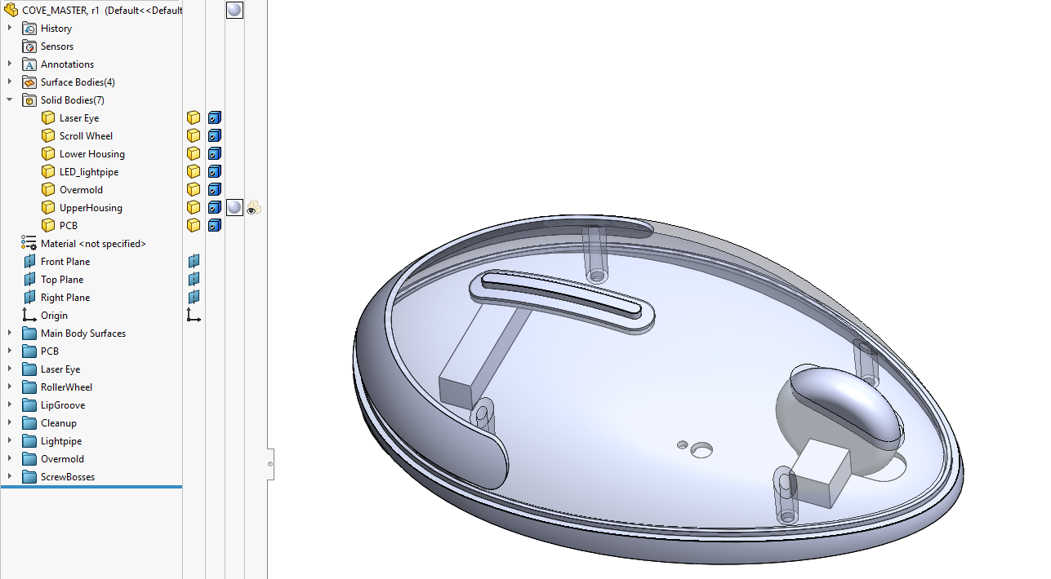
Master Model file has basic part interfaces and core surface geometry defined. Parting line is defined and main parting line draft is specified.
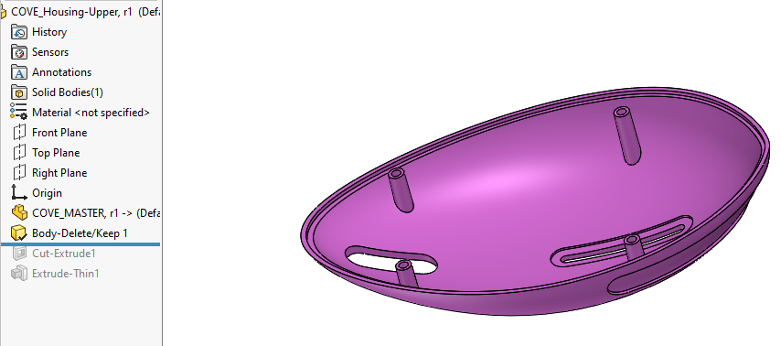
Child part creation: Insert Part (Master Model)

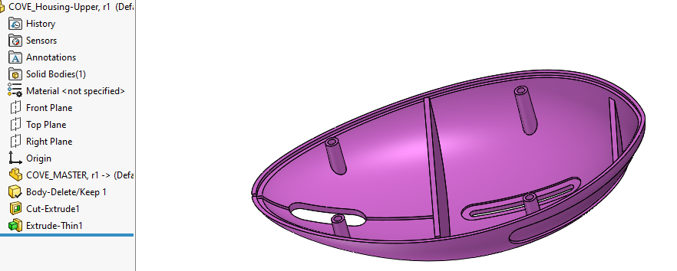
Delete/Keep Bodies (upper housing)
Add any additional features in part (non-mating ribs, part-specific draft, fillets, etc.

3D CAD – Manufacturing Review
Injection Molded / Die Cast Parts
- Draft Analysis run, draft is acceptable for providing the desired surface finish (generally 1 degree for up to around 1” of feature depth)
- Thickness Analysis run, no issues
- Shut off faces (mold steel coming into contact with mold steel during the closing of the mold) to be drafted 3 degrees or more
- Thin knife-edges of steel in mold are avoided
- Undercuts or side-actions/cams are approved by mfg or engineering
- Boss wall thickness and reinforcing ribs to be 40-60% of the nominal wall thickness.
- Wall thickness not too thin in which case leads to lack of fill issues
- Wall thickness correctly sized in areas to avoid shrink on cosmetic faces.

Sheet Metal Parts:
- Features are modeled with Sheet Metal tools, and allows unfolding to create flat pattern
- Standard thickness/gauge sheet metal is applied.
- Tabs and features near bends are reviewed with mfg

Machined Parts:
- Internal fillets for machined corners are appropriately sized.
- Deep drilled holes are confirmed with machinist (5-10x diameter, ask questions, 10x dia is tricky)
- Parts modeled with operations in mind, minimizing setup to minimize cost

Assemblies:
- The 3D Assembly file should be fully constrained as it would be in the actual assembly.
- Threaded inserts in assembly
- Screw engagement is sufficient (2-3X diameter)
- Adhesive or glue inserted into assembly as phantom part (no geometry) to ensure BOM is correct
- Purchased components have their Part Number, mfg, and misc metadata in part properties

